Practice Project 1: Set Up and Create a Git Repository

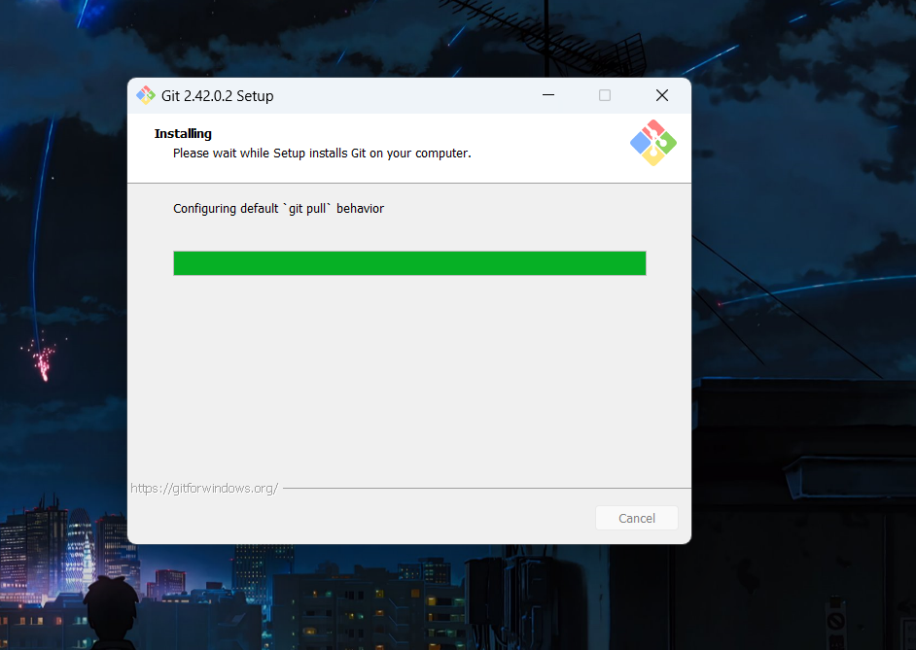

Fig1: Installing the Git into the System

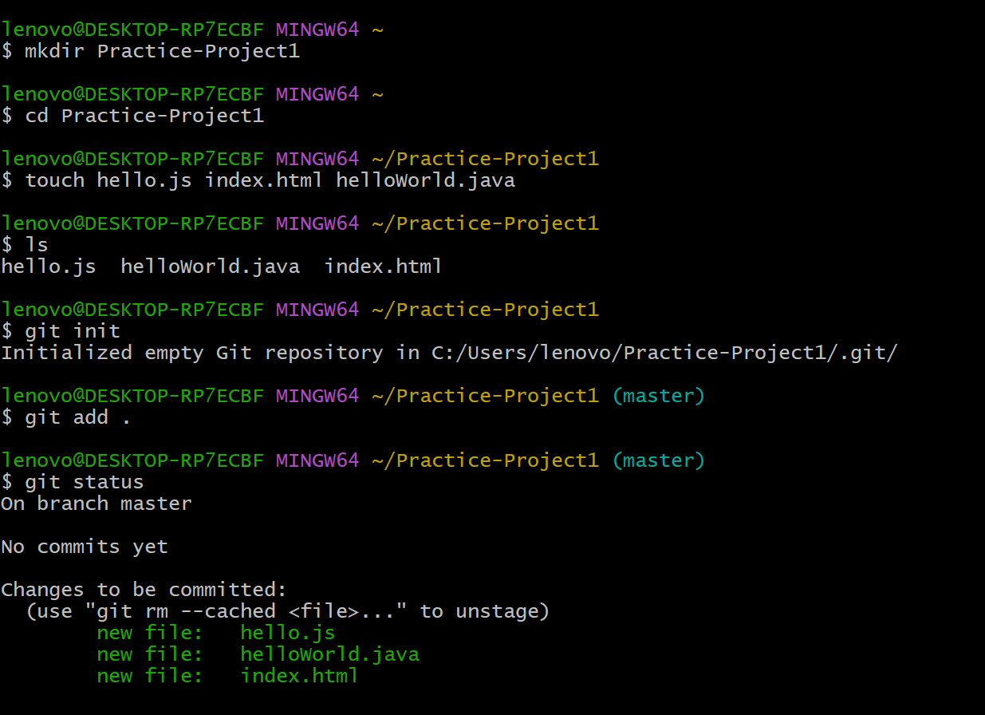

Fig2: Creating files and git repository

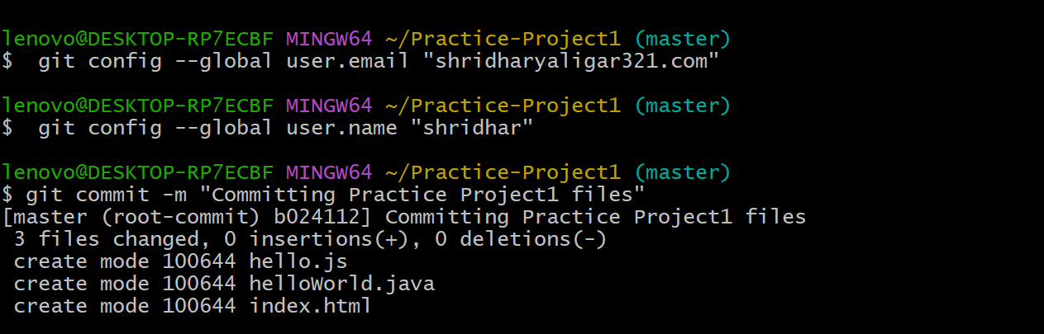

Fig3: committing the files